|  |  |  |  |
| --- | --- | --- | --- |
| **Proposed Scope of Notification** | | | |
| Address: | **57 – 61 Bourke Street, North Parramatta** | Proponent: | **LAHC** |
| Property Description: | **Lots 23, 24 & 25 in DP 35290** | Job No: | **BGX6WW** |
| LGA: | **City of Parramatta Council** | Planner: | **Rajlaxmi Kshirsagar** |
|  | |  | |

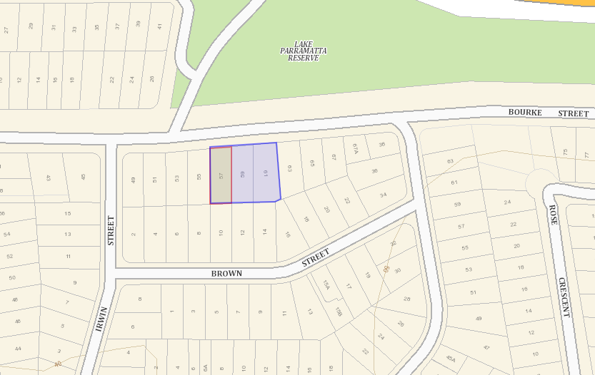

**Legend**

**Site**

**Properties proposed to be notified by LAHC**